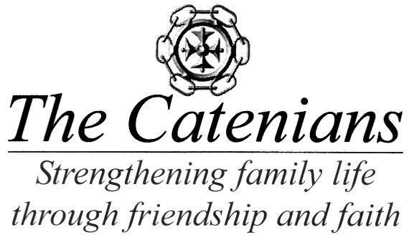

THE CATENIAN ASSOCIATION
Malta Week 2019 Coordinator
Joe Caruana, “Clarach”, Triq San Gwann
l-Evangelista, Bahar ic-Caghaq, NXR 5203, Malta
Tel: + 356 21375085, +356 99471114
E-mail : clarach@onvol.net

The legal status of Malta Week

At the request of the Association Secretary we are writing to ensure that the way in which Malta Week is organised is clearly understood.

Any package offered to UK residents, air travel, hotels tours and other services, and run by a commercial organisation, has to be covered by an ATOL licence. This gives protection against the failure of the company, or the airline involved. There is, of course, a cost involved in applying for such a licence.

The Association is not a company and falls within the UK definition of a “Club”. As such, we are entitled to run events such as Malta Week without the need of an ATOL licence. We have obtained an opinion from the Civil Aviation Authority ATOL Enforcement Office that we are exempt, since we only offer attendance to members, their families and friends, and widows of members. The package is not available to the general public.

Whilst this keeps costs down, it does mean that the ATOL cover described above is not operative. However, the Malta & Gozo Area Council issues an assurance that its responsibilities are taken seriously. We are not a company, so we cannot go bust. All monies received are kept in a separate Catenian bank account and normal rules of signatories, audit, etc are followed.

On any trip there can, of course, be many possibilities of illness, theft, or other unfortunate circumstances. Although the Committee tries to assist in cases of any difficulty, we strongly recommend that holiday insurance cover is taken out. To fully protect oneself, insurance cover should be also sought to include protection against airline failure, although this is unlikely.

28th March 2019

